## horizontal line

AdvPictionary

An improved online pictionary python game with multiplayers, and an inbound chat app using python game library, and sockets and user authentication.

Joseph Sigawa

Web developer and designer and a very talented software engineer

# Resources

In this project, the main resource will be python.

Most importantly the profound python libraries, such as, game, user_auth, server etc.

The list is not limited to this and can grow as I progress with the project..

I chose python as the main technology in this project and I believe that at the end of this, I would have reached the point I wish to be.

I must say I am a very profound user and well skilled PHP web developer and MySQl and I have achieved several milestones as far as this is concerned. But, I wanted something more robust and that could pose a real challenging opportunity for me to master the so-called sweet technology (python).

**Framework or Frameworkless!**

I am deciding to go frameworkless, (oops)... but yes, it may sound tedious but yes, I like to understand the ins and outs in this technology (just as i did with PHP).

# Challenge Statement

From [my portfolio](https://jos254kenya-portfolio-home-95z8hl.streamlit.app/) I described how learning software engineering have opened my inner mind and way of seeing things around me and far from me.

This project would mainly lead to general understanding of the python concepts. Based on the description, other challenges areas such as server side and User authentication will be explored.

I originally intended to make an app (mobile) but, I fear this would not be achieved at this juncture because I wish to use the end product of this point as a key to move forward to that. I really wish to explore and advance my skills in the python world. I might not be sounding “python-like” or “software-engineer-like” but trust me, I am not perfect in talking, rather I prefer action.

## Relevance

This project is relevant to the current(already) covered concepts on the ALX.

# Risks

1. Schedule

I found it more challenging to be able to deliver within the expected time, while at the same time, working on other daily projects as far as life sustainability is concerned. Taking into account that I am not employed at the time of writing this proposal

1. Budget

I would honestly say that the cost of data has become a nightmare- especially in cases where there is no public wiFi.

As for this project, the cost data is significantly high and this could be reduced if i had a public WiFi.

1. Operational
2. Technical
3. Programmatic Risk

This risk could be the main because am afraid that somewhere in the process I mighty fail to get things right as am a newbie to this kind of development.

# Infrastructure

All of this project resources will be hosted in the main branch of my GitHub repository. (I know how important it could be to work as a team, but unfortunately after deferment, i could no longer have access to my peers who were willing to join me.)

# Existing Solutions

The online pictionary game is not new and there is a bunch of them already out there. But, in almost more than three quarters of them, none addressed the idea of inbuilt chat app (which to me, is very crucial as it also involves user auth and end-to-end encryption)

# Architecture

As already pointed out, this project may/could be a (close) replica of the already existing pictionary games out there. I took it as a challenge to be able to create mine and help me learn through game libraries.

The architecture is an improvement of the one represented [here](https://youtu.be/wDIQ17T3sRk) .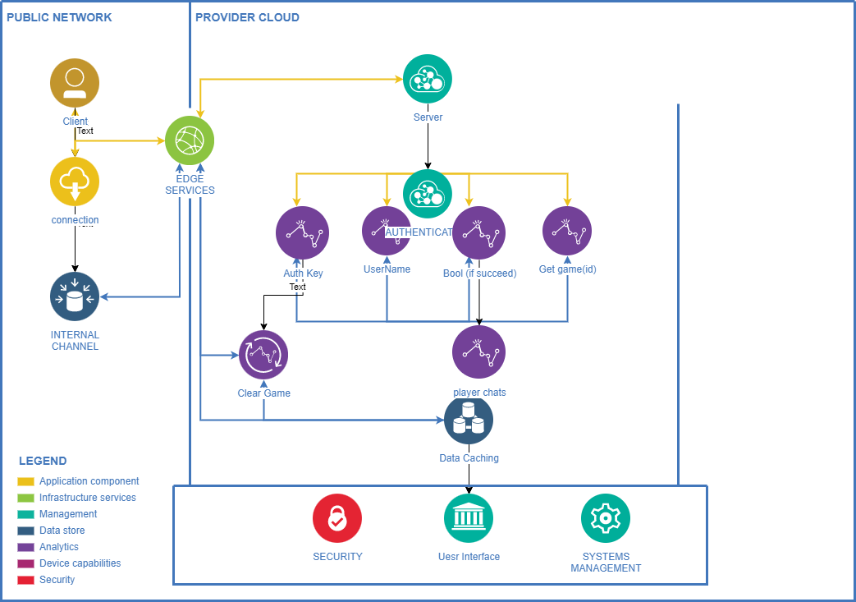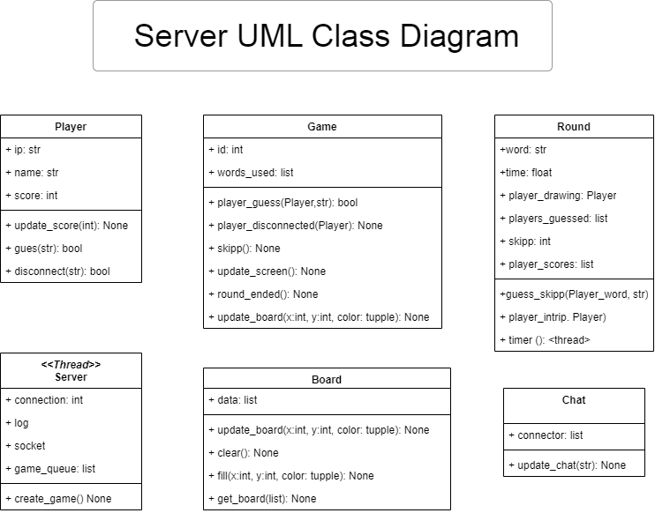

# APIs and Methods

As described from the UML class diagram, these are the most common APIs that will be involved in the game code.



# Data Modelling

The simple (not full) data model diagram is shown below

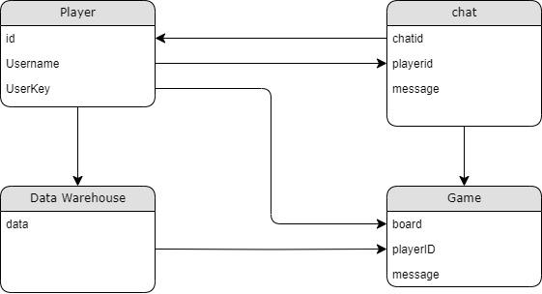

# User Stories

1. How would it feel to play a mind-blowing and relieving yet a relieving game? I would probably like to play the game, and at the same time feel free to challenge real humans and not robots, by doing so it would encourage me to learn more about the game, and eventually aspire to create mine just like that.
2. How secure would you be when you know you can use any username just for the purposes of fun? No real names, no real user-data, just fun, and you get to know other fun names too while playing the game.
3. I would like too, to play and chat along with friends and even ask them out for a single vs combat! That would be a sweet thing to do!

# 

# Mockups

